Cathedral High School Class of 1958 50th Reunion Classmate Book
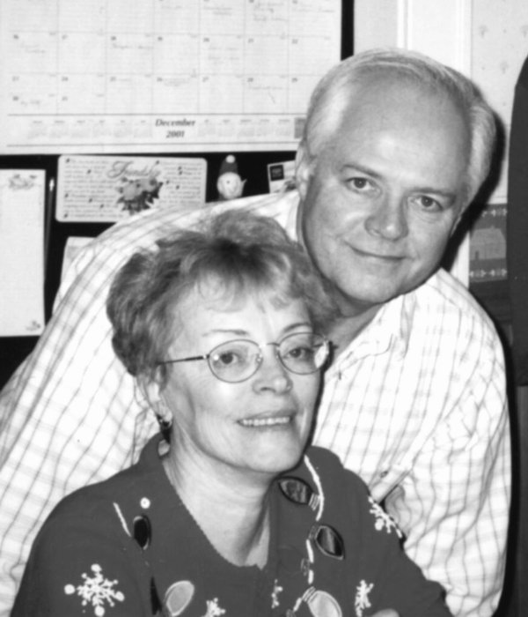
Classmate:
Address:
City, ST, Zip:
Tel:
Email:
What are you doing now?

We raised 7 children and currently have 10 grandchildren. I retired in 2002 and now Kathy and I have more time to enjoy our family; especially visiting our children in & out of Vermont and have visited them yearly in Hawaii and Salt Lake City since I retired. We spend time on yearly family calendars, and numerous photo and scrapbook projects. Being the 10th of 14 children, we have a largely attended annual Family Picnic at Oakledge Park and an annual Family Christmas party at St Joseph’s Parish Hall. In the summer I enjoy tending my garden and many flower beds in our yard. After the summer is gone, Vermont has great computer weather and I manage to spend an awful lot of time working, playing and tending the beast at times. Since Kathy and I don’t share our toys well, she has her own computer and I have another so that I can keep up to date with the Linux system, and then a laptop for the road. I also put in a lot of time at the Vermont French Canadian Genealogical Society that I co-founded in 1996. Our very large ongoing project at VT-FCGS is the publishing of the Marriages and Baptisms of all the Catholic Churches, up to 1950, in the Diocese of Vermont, with the approval of the bishop. We have completed 27 books to-date and we should be busy for another ten years.

Employment History –

After school I joined the U.S. Navy for 4 years and flew in a P2V Neptune, hunting submarines.

After I worked at Simmonds in Vergennes where they made fuel gauges for the Boeing 707 and for the Apollo Command Module.

In 1964 I joined IBM in Burlington and worked for 10 years as an electronic technician and 28 years as a computer programmer on several of their Manufacturing Control Systems.
Comments:

We were all saddened to lose Carol Corey Duncan. She has done so much for our class over the years. However, this has forced us to come together as a committee to get the 50th Reunion started, and it has been enjoyable to meet with my classmates again. We are a fun group and we are managing to get things organized and off to a good start. I look forward to meeting all of my classmates at our 50th Reunion in 2008.
